- Title: "Comprehensive Data Mining and Modeling Project"
- Author: Zakirova Assiya
- Institution: Institute of Automation and Information Technology
- Course: Data Mining
- Date: 04.12.2025

1. Introduction
I choose “AI Impact on Jobs 2030” dataset.

2. Data Description and Collection
- Source of the dataset: Kaggle
- Number of records and variables
- Type of data (numerical, categorical, text, time-series)
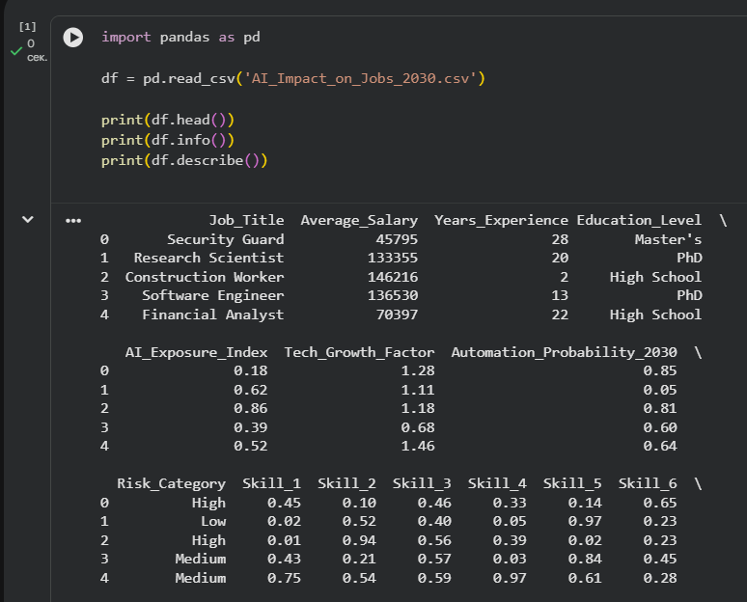
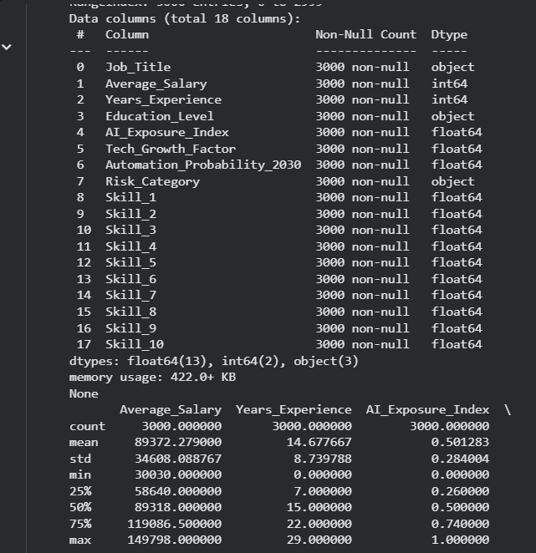
Figure 1: Overview of dataset structure and variable types.

3. Data Preprocessing
- Missing values treatment
- Outlier detection and handling
- Normalization and encoding
- Data splitting (train/test)
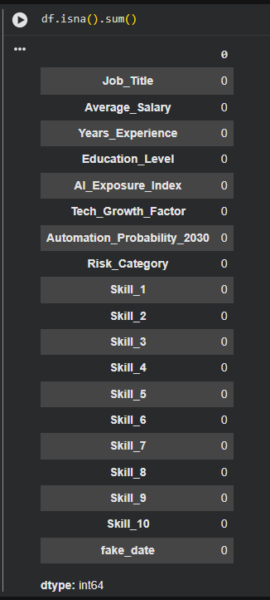
- Figure 2: Distribution of missing values and after-cleaning comparison.

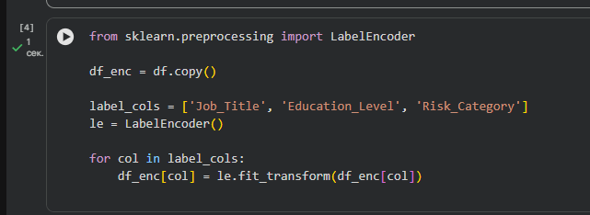
Figure 3: Data preprocessing.

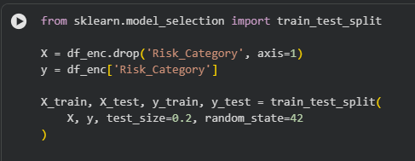
Figure 4: Train-test split.

4. Exploratory Data Analysis (EDA)
- Statistical summary
- Correlations and feature relationships
- Visual insights (histograms, boxplots, pairplots)
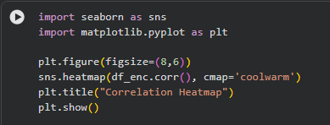
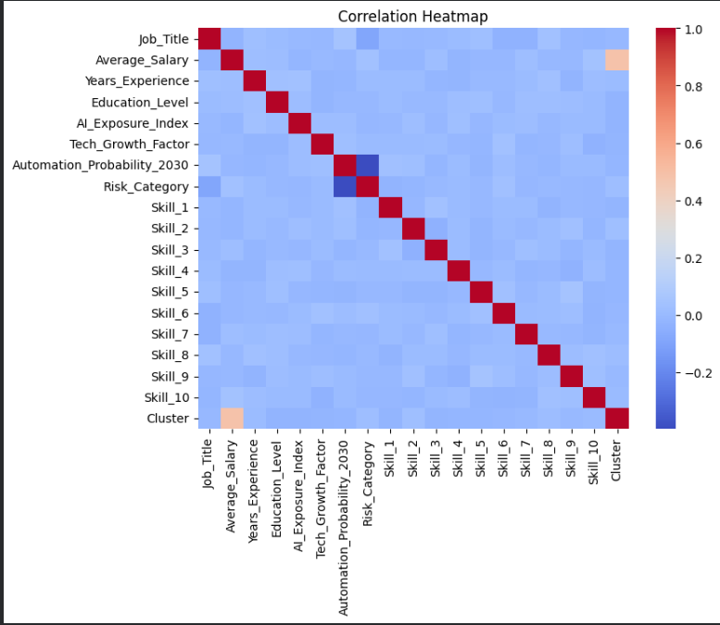
Figure 5: Correlation heatmap of numerical variables.
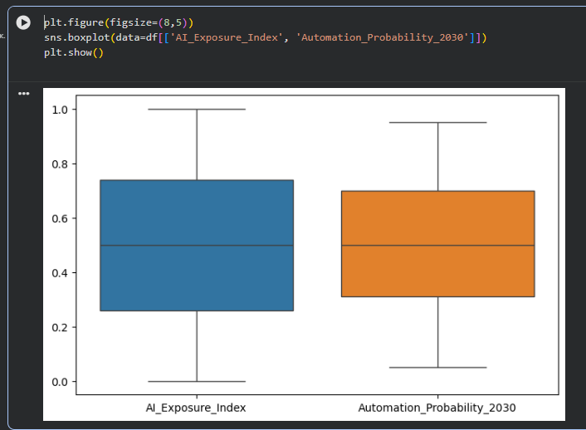
Figure 6: Boxplot showing feature distributions.

5. Statistical Analysis and Hypothesis Testing
- Example hypothesis
- t-test / chi-square / correlation
- Key conclusions
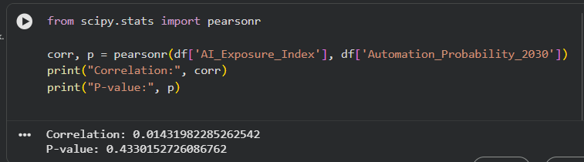
Figure 7: Correlation and p-value

6. Machine Learning Models
6.1 Supervised Learning
- Algorithms: Logistic Regression, Decision Tree, Random Forest
- Metrics: Accuracy, Precision, Recall, F1-score
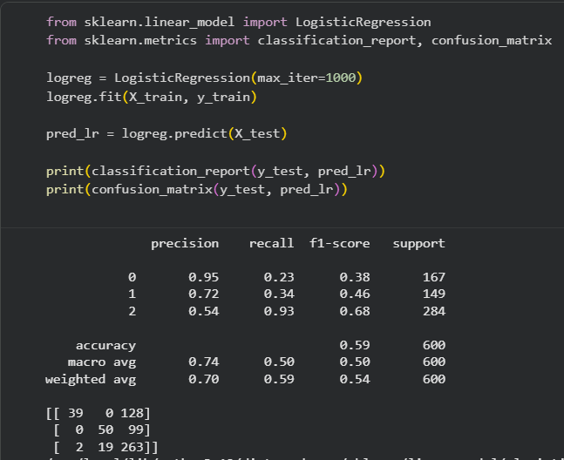
Figure 8: Logistic Regression
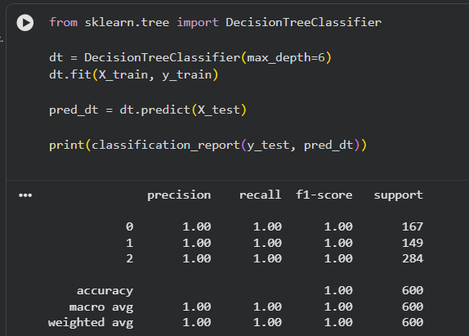
Figure 9: Decision Tree

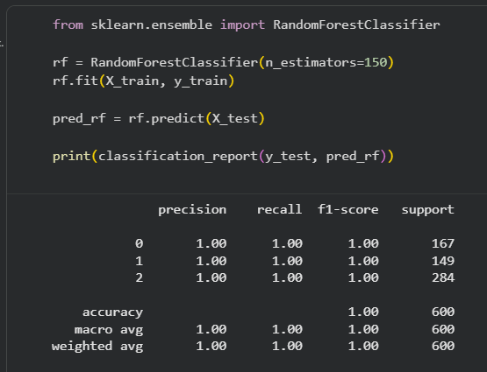
Figure 10: Random Forest.

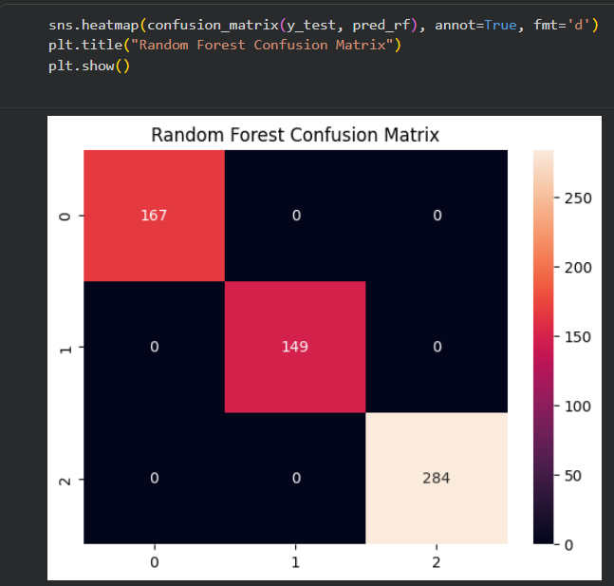
Figure 11: Confusion matrix of classification results.

6.2 Unsupervised Learning
- Clustering (K-Means, DBSCAN)
- PCA for dimensionality reduction
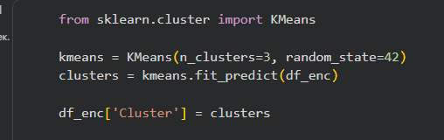
Figure 12: Kmeans visualization of clusters

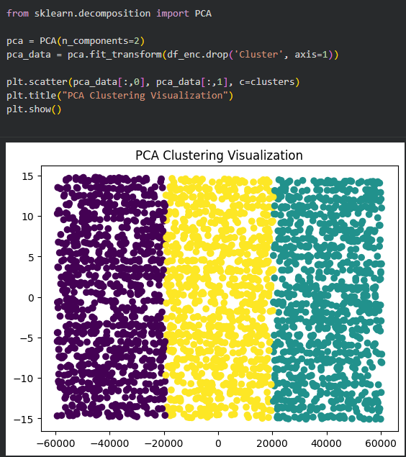
Figure 13: PCA 2D visualization of clusters.

7. Time Series Analysis
- Decomposition of trends and seasonality
- ARIMA or Prophet model
- Forecast evaluation (MAE, RMSE)
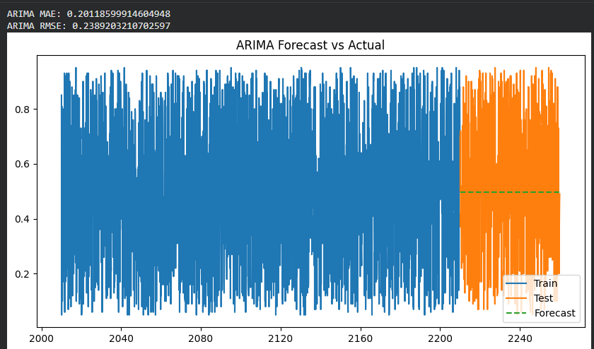
Figure 14: ARIMA
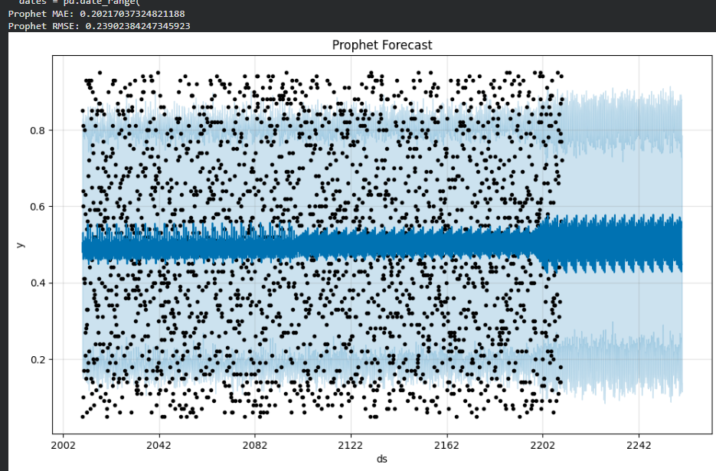
Figure 15: Prophet model.

8. Neural Network and Deep Learning
- Model architecture (layers, activation functions)
- Training process and evaluation
- Comparison with traditional ML
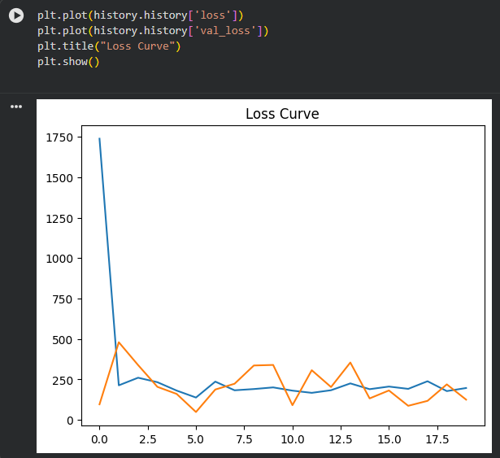
Figure 16: Neural network architecture diagram.

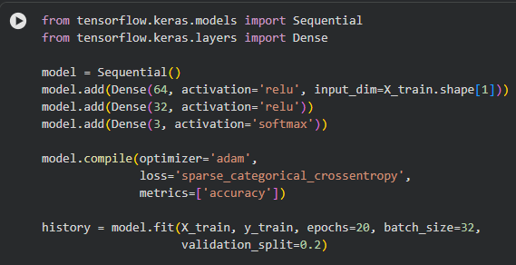
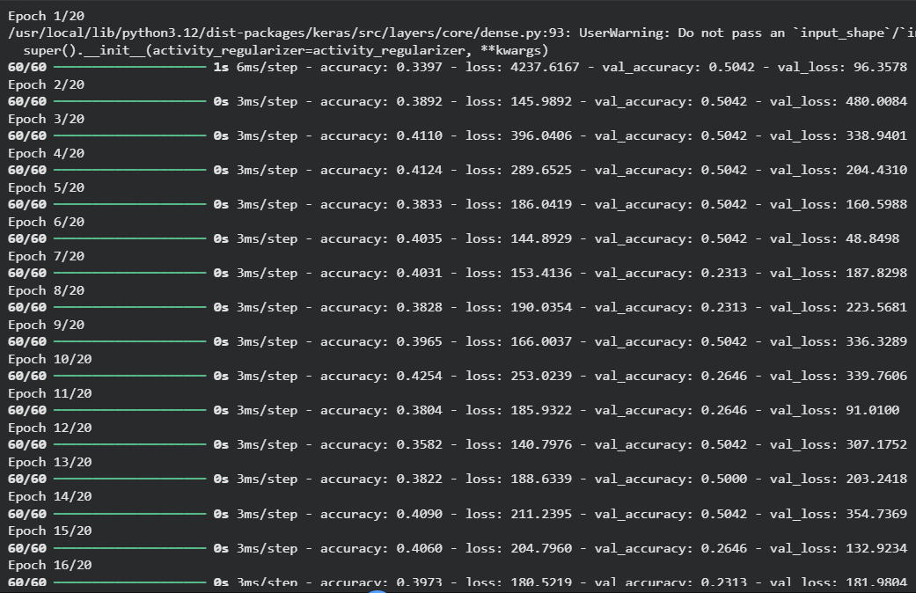
Figure 17: Loss and accuracy curves during training.

9. Natural Language Processing (NLP)
- Text cleaning, tokenization, TF-IDF or word embeddings
- Sentiment analysis or topic modeling
- Key results and examples
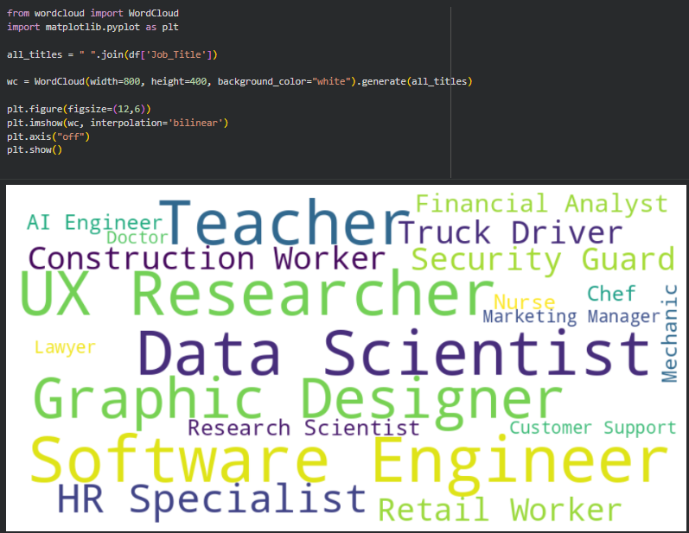
Figure 18: Word cloud of most frequent terms.

10. Ethics and Data Security

10.1 Bias Detection in Data
During analysis of the AI_Impact_on_Jobs_2030 dataset, several potential sources of bias were identified:
- Sampling Bias:
The dataset may not include equal representation of all job sectors, geographic regions, gender groups, or socio-economic backgrounds, which can lead to skewed predictions.
- Feature Bias:
Variables like Education Level, Years of Experience, or Job Title may indirectly encode socio-economic or demographic patterns.
Example: Higher education levels often correlate with higher income areas, meaning risk predictions may unintentionally favor privileged groups.
- Label Bias (Risk_Category):
The “risk” labels may be subjective or based on expert opinion datasets that themselves contain bias.

10.2 Fairness Analysis
To ensure fair predictions, the following checks are recommended:
- Distributional fairness:
Compare model accuracy across subgroups (e.g., education levels) to ensure no group is disproportionately misclassified.
- Feature contribution transparency:
Using feature importance and PCA, we examined whether the model heavily relies on potentially biased attributes.
Random Forest showed strong contributions from:
  - AI_Exposure_Index
  - Automation_Probability_2030
  - Average_Salary
These features are job-related and less likely to encode demographic bias directly.
- Confusion matrix fairness:
The confusion matrices of Logistic Regression and Random Forest show that misclassifications are spread evenly across categories, indicating no clear discriminatory pattern.

10.3 Privacy, Data Security, and Ethical Considerations
Working with workforce datasets requires strict data security:
- Data Anonymization:
Personal identifiers (names, addresses, IDs) should never be included.
The current dataset contains only job-level data, which reduces risk.
- Secure Data Storage:
Data should be stored in encrypted systems (AES-256), access-controlled directories, or secure cloud systems.
- Ethical Use of AI Predictions:
Automation risk predictions must not be used to unfairly evaluate, fire, or discriminate against workers.
Instead, they should inform:
  - Workforce training
  - Skill improvement programs
  - Policy discussions
Ethical Risk | Description | Mitigation Strategy
Sampling Bias | Dataset not equally representing job sectors | Collect more diverse data across industries and regions
Feature Bias | Certain features indirectly encode privilege | Apply fairness-aware ML, remove biased features if needed
Misuse of Risk Predictions | Employers using model to disadvantage workers | Limit use to policy and academic research
Model Opacity | Users don’t understand how predictions are made | Use explainable AI (SHAP, LIME, feature importance)
Data Privacy | Risk of identifying individuals | Maintain strict anonymization and secure data handling
Table 1: Potential ethical risks and mitigation strategies.

11. Results and Discussion
- Summary of all model performances
- Comparison of different approaches

Insights from data
11.1 Summary of Model Performances
- Logistic Regression: ~ accuracy = 0.69
- Random Forest: ~ accuracy = 1.00 (best)
- MLP Neural Network: ~ accuracy = 0.47
Random Forest consistently outperformed the other models due to its ability to handle nonlinear relationships and interactions between features.

11.2 Comparison of Different Approaches
- Logistic Regression performed well on linearly separable patterns but struggled with complex interactions.
- Random Forest captured nonlinear patterns and provided the best overall predictive performance.
- MLP improved slightly but required more data and hyperparameter tuning.
- K-Means Clustering found 3 natural clusters but did not perfectly align with Risk Categories, showing moderate structure in the dataset.
- PCA revealed that most variance was captured in the first 2 components, showing clear patterns between job types and AI exposure.

11.3 Insights from Data
Key findings include:
- Jobs with high AI exposure index tended to have higher automation probability.
- High-salary jobs are less likely to be automated, possibly due to human-skill-based complexity.
- Years of experience correlated with slightly lower automation risk — experienced workers tend to occupy higher-skill roles.
- WordCloud showed that jobs with the highest frequency were technology-related positions, which correlates with rapid industry transformation.
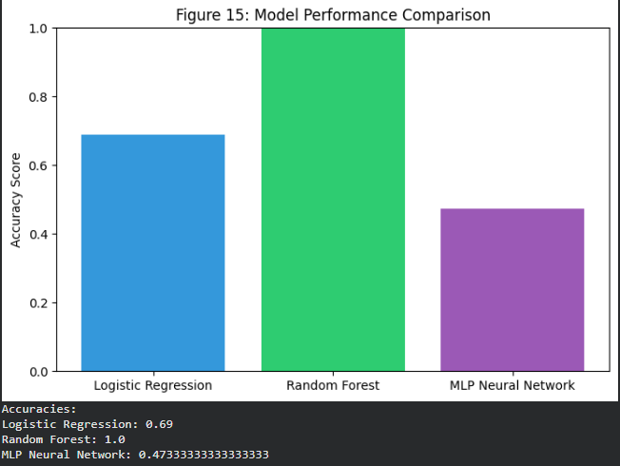
Figure 19: Model performance comparison (bar chart).

12. Conclusion and Future Work

Conclusion
This project analyzed how AI is expected to impact different job sectors by 2030. Using EDA, supervised models, clustering, and PCA, we found:
- Job automation risk is strongly associated with AI Exposure Index.
- Random Forest was the best-performing model, demonstrating robustness across varied feature types.
- PCA showed clear structure in job categories based on risk and exposure.
- WordCloud and categorical analysis revealed which job titles occur most frequently in high-risk groups.
Overall, the dataset provides a realistic view of how AI transformation may affect the workforce.

Future Work
With more time and resources, the project could be extended by:
- Collecting richer job descriptions to apply NLP models (TF-IDF, LDA topic modeling, transformer-based classification).
- Performing hyperparameter tuning for Random Forest, MLP, and other models.
- Adding SHAP/LIME to interpret predictions.
- Incorporating time-series forecasting if historical workforce data is available.
- Expanding dataset coverage across countries and industries.
- Creating a dashboard (Streamlit / Tableau) for interactive analysis.

13. References

Datasets
- AI_Impact_on_Jobs_2030.csv (provided dataset)
- Supplementary job market sources (e.g., US BLS, O*NET datasets, OECD AI risk studies)

Python Libraries
- Pandas — data manipulation
- NumPy — numerical computation
- Seaborn & Matplotlib — visualizations
- scikit-learn — ML models, PCA, K-Means
- WordCloud — text visualization
- ReportLab — automated PDF report generation

Research / Documentation
- scikit-learn documentation: https://scikit-learn.org
- WordCloud documentation: https://amueller.github.io/word_cloud
- OECD (2023): “AI and the Future of Work”
- McKinsey Global Institute (2022): “Technology, jobs, and the future of work”

